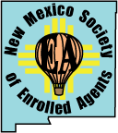

New Mexico Society of Enrolled Agents
October 2022 Conference

Thursday 10/27 (7:30AM – 5PM)
and Friday 10/28 (7:30AM – 5 PM)
$300 NMSEA members (early bird)

Featuring In-person Speakers:

Ellen Briscoe, EA, ATA Trusts and Preparing that Tax Return
Lelah Martinez IRS Liaison Report
Lynne Shupp, EA, RFC Ethics
Ruth Tribou, EA Retirement and Casualty Losses
Brad Yablonski Social Security Issues

You have the choice of attending either virtually or in-person at
Courtyard by Marriott
5151 Journal Center Blvd NE
Alb, NM 87109
(Room rate discount will be available)

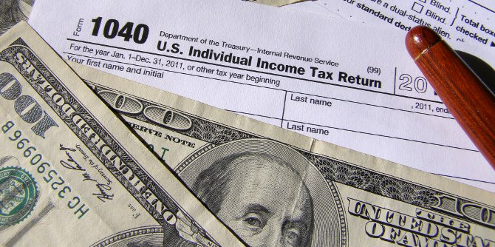
This Photo by Unknown Author is licensed under CC BY-NC

Tickets and reservations will be offered through Event-Brite (coming soon)

